London dominates the life of Britain. And it is the greatest and nicest town in the world. Also, the nature of this city is very picturesque. There are a lot of sites and places of interest here. Many parks and theatres, museums and halls, which are always ready to surprise tourists and English with it’s beauty and charm. There are about 40 theatres, several concert halls, many museums including the British Museum, and the best art galleries.
Speaking about parks we can always see many people here listening to others or just heaving their rest. Hide Park with its Speaker's Corner is also in London. Among other parks are Kensington Gardens, St. James Park. In the West End is Buckingham Palace, which is the Queen's Residence, and the Palace of Westminster the seat of Parliament. The best-known streets here are Whitehall with important Government offices, Downing Street, the London residence of Prime Minister and the place where cabinet meets, Fleet Street where most newspapers have their offices, Harley Street where the highest paid doctors live, and some others. There are many statues and monuments there. I think that the majority is devoted to the famous and outstanding people.
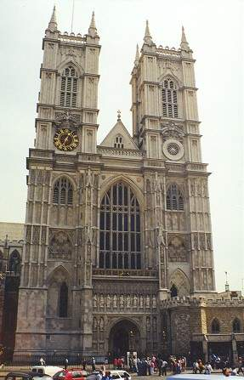London Is situated upon both banks of the River Thames and it is one of the largest cities in the world. Speaking about the West end of London we mean it’s center where famous parks and tropical places are situated. In Westminster Abbey begins and comes to an end royal destiny: in its walls the British monarchs are crowned, here they find their eternal rest. Besides Westminster Abbey is well known for the " poet’s Conner ". So… many others memorial boards are established. But the present tombs are far from being all mentioned to the poets.
Well it is safe to say that it is the most famous building in England. It is a fine Gothic building, which stands opposite the Houses of Parliament. It is the work of many hands and different ages and the oldest part of the building dates from the 8th century.

While speaking about a Tower I want to say that the Tower has been part of the capital's history for the past 600 years. The Tower of London is a very old building. It is more than 900 years old. English kings lived in it many years ago, but now it is a museum. People, who come to London, like to go to the Tower. It was a fortress, a royal palace and later a prison.
The White Tower, dating from 1078, contains a spectacular collection of arms. Now The Tower protects the Crown Jewels. The Imperial State Crown and the Crown of Queen Elizabeth both incorporate precious stones whose history goes back centuries. Ceremony is still part of the daily life within The Tower. Following a 700-year tradition, each night the Chief warder locks the gates and hands the keys to the Resident Governor.
And now we can talk about a Tower Bridge of London.

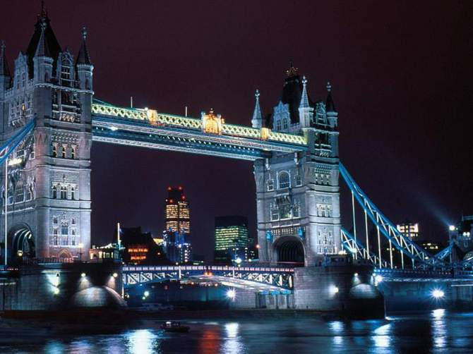

London's best known and most distinctive bridge has straddled the Thames for a century. The twin draw-bridges, each weighing about 1,000 tons, have been raised more than half a million times since the bridge was built. It is a working tribute to Victorian engineering genius. The draw-bridges take just 90 seconds to rise. All the original machinery is still in place with just one concession to modern technology: electric motors now replace the steam engines. Between the massive gothic-style towers that rest on the river bed are walkways, giving superb views of the river and the Tower of London.
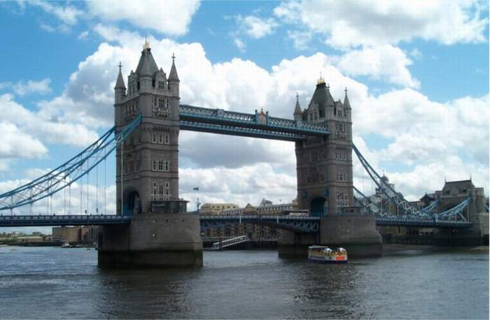

Now we can talk about BIG BEN!!
Big Ben is the name of the huge clock in one of the tall towers of the Houses of Parliament. People are allowed to get inside the Tower so that they can see the works of Big Ben. There is no lift and there are 340 steps up to Big Ben. The faces of the clock are very large.
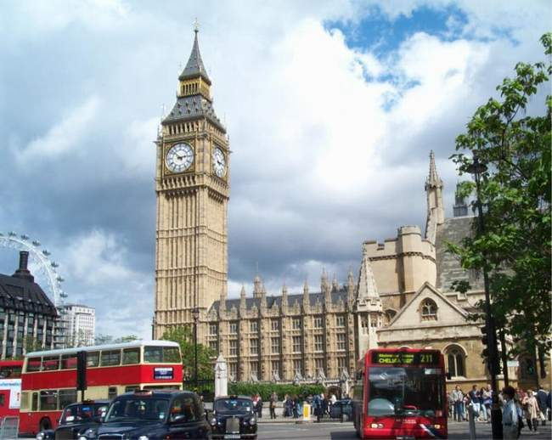

The sound of Big Ben is well-known to all British people and the tower of Big Ben is often used as a symbol of Britain. The great bell got its name in 19th century after Sir Benjamin Hall. Big Ben is the voice of London; it shows an exact time since 1859.
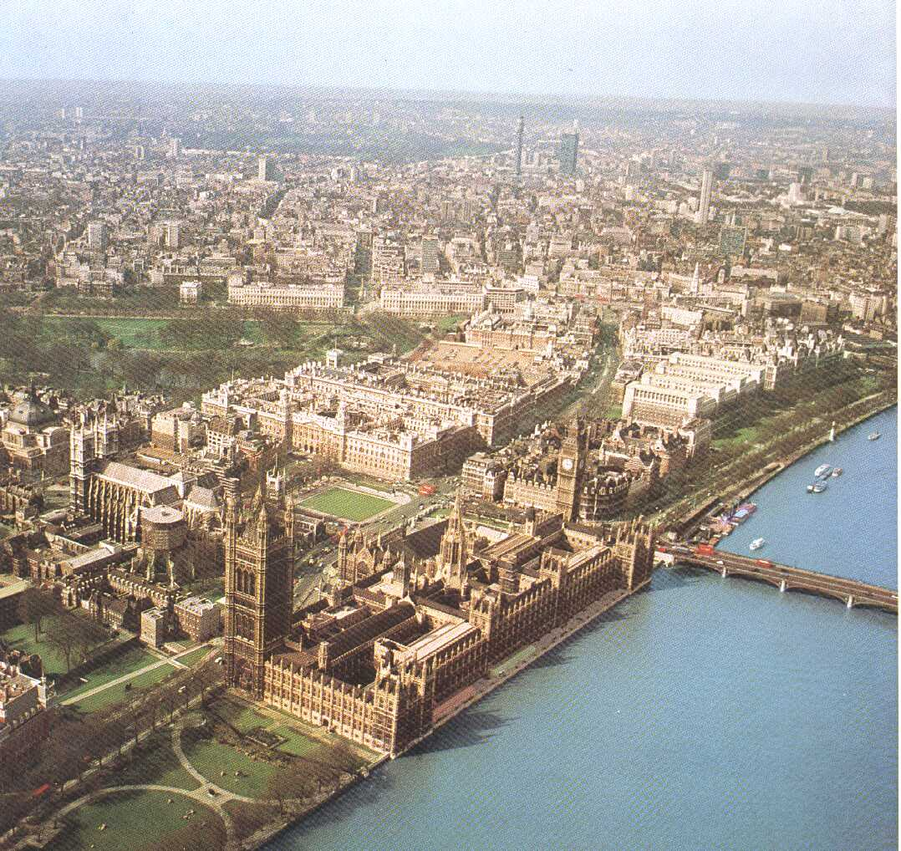

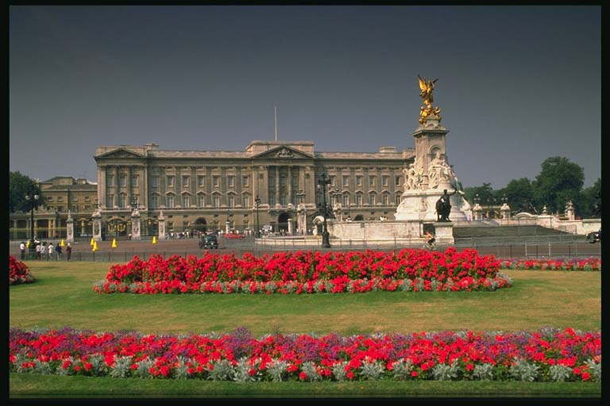Therefore there are many nice squares in London. Trafalgar Square is one of them and it is situated in the center of the West End. There you can see a statue of Lord Nelson named by Nelson’s Column, which is situated in the middle of the square. Trafalgar Square commemorates Nelson's naval victory of 1805. It was laid out between 1829 and 1841. There is Nelson's column there, nearly 185 feet high topped by statue of Nelson 17 feet high. The fountains and friendly pigeons make Trafalgar Square a popular place for Londoner and tourists. The building of National Gallery - one of the world famous art museums is situated on the Trafalgar square too.
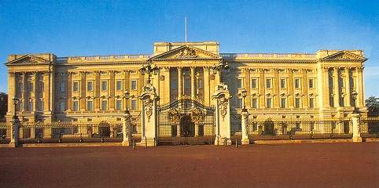Now we can tell few words about Buckingham Palace. It has served as

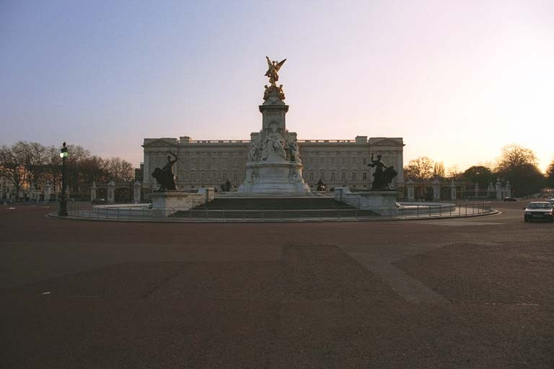the official London residence of Britain's sovereigns since 1837. It evolved from a town house that was owned from the beginning of the eighteenth century by the Dukes of Buckingham. Today it is The Queen's official residence. Although in use for the many official events and receptions held by The Queen, areas of Buckingham Palace are opened to visitors on a regular basis. The State Rooms of the Palace are open to visitors during the Annual Summer Opening in August and September. They are lavishly furnished with some of the greatest treasures from the Royal Collection - paintings by Rembrandt, Rubens, Vermeer, Canaletto and Claude; sculpture by Canova and Chantrey some of the finest English and French furniture in the world.
Visits to Buckingham Palace can be combined with visits to The Queen's Gallery, which will reopen in the spring of 2002. The nearby Royal Mews is open throughout the year.
Well… it is safe to say that a have finished my story about the nicest city in the world, exactly London and about all it’s sights, beauties and places of interest of course. As for me I’d like to visit it again, to feel everything I felt before, spending there my free spring time and therefore I’d like to know english better and that’s why I advise all of you to visit this irresistible city!


