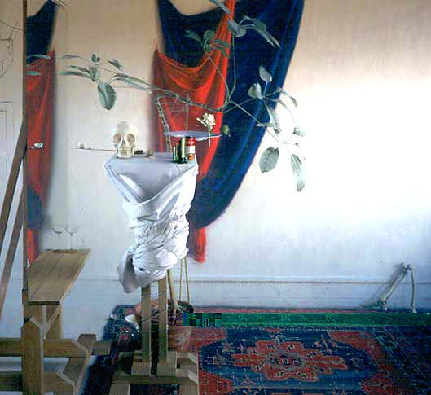
Daniel Sprick’s “Release Your Plans”

Critical Review

I am analyzing Daniel Sprick’s “Release Your Plans” painting, which is located in Denver Art musuem’s seventh floor. The painting was painted in 2001, and it is an Non-objective painting with oil on panel painting. By looking at this painting, one can be a little frustrated. The painting creates some sort of confusion. It is hard to focus on one small part of the painting because there are things going on all over the canvas.
The painting is a painting of some artist’s studio, because you can see an easel, and some paint. On artist’s easel, there is a broken glass of beer, a tomato soup called “your plans”, a skull with pins in its eyes, an egg shell on a knife, and some dead cockroaches. There is a mirror in front of the easel that reflects the outside of the room, which is a lot more prettier than artist’s studio. The mirror is standing on the stand, and there are some broken candle holders with figures of angels. Behind the mirror, there is a note attached to the wall that says something like “desnity and plans.” On the right of the easel, there is rose that is tied down, and kind of curved, and this rose is tied to an easel, and easel is tied to the mirror, so as if on of these objects fall down the rest two will fall down too. There are roses in the air not attached to anything. The floor is dirty, and full of cigerette butss, on the corner of the painting there is a leg bone of a human, and somewhere on the right low corner there is an object lift off the ground, standing on its own.
Everything in this picture looks in its natural form, but not in their natural environment. Roses in the air not attached to anything, or skull on easel with pins in its eyes are some of the things that strikes me most about this picture. There aren’t any extraordinary mixture of colors. Everything looks in its natural color. The whole picture depictes life of people. By seeing all these different object, we ca associate them with our everyday life details. If the painting is looked in general, then we could see every persons life in there. Every object is placed in order to create a perfect balance in the picture. This is a 3 dimensional painting, and he achieved this by using linear perspective.
I think artist is trying to convey in this painting how life can get messed up sometimes, in his painting you can see a lot things going on, and we could relate that to our life. Roses could be best representations of good things that happen in our life, and other broken glasses, and cigarette butts, or skull could be a representions of bad things that happen in our life. Artist was able to convey his complicated messege about life through simply drawing of simple objects. Even though every object seems to be objects we see everyday, the messege they convery is completely different.

