Estonian Towns
Narva
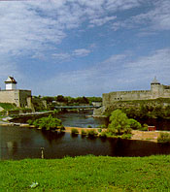
The city of Narva is located in Northeastern Estonia, on the border between Estonia and Russia, 210 km from Tallinn and 150 km from St. Petersburg. Every town has its own face which sets it apart from all other places. If you have never seen the unique view of two ancient frontier fortresses facing each other across a river, you should come to Narva to see the Hermann Castle on the Estonian side, and the Ivangorod Castle over on the Russian side.
If you have never before seen Swedish medieval fortifications, in Narva you will find those which previously enclosed the town, making it one of the most powerful fortresses in Europe.
If you are interested in history, you might visit the Narva Museum, housed in the famous Tall Hermann Tower. There you can acquaint yourself with displays about the history of Narva, its pre - war architecture, and the household implements of its citizens.
If you are an art-lover, visit Narva Art Gallery, a very cosy and pleasant place, located on the Gloria Bastion in the former military barracks. The main exhibition area holds the art collection of merchant named Lavretsov, and there are regular temporary exhibitions of art from Estonia as well as from other countries.
If you would like to see an unique example of the industrial architecture of the 19-th century, you can take a look at the buildings of the Kreenholm factory. The factory, the biggest cotton enterprise in Estonia, is located on Kreenholm Island, which divides the Narva river into two arms.
If you wish to relax for a little while at the seaside, come to Narva, which is only 14 km from the Gulf of Finland.
In the summer resort named Narva-Joesuu, you will find a pine forest, fresh air, sea, watch the waves from glittering sand-dunes on the 4 km beach and enjoy peace… Here you can choose between three health spas and receive expert physical treatment from head to toe.
Tartu
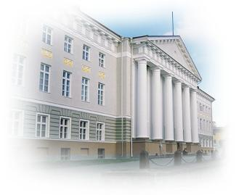
For ages Tartu has been known as the city on the crossroads where people from far and near meet. During the active days of the Hanseatic League Tartu became a trading centre for merchants from east and west.
Tartu is one of the oldest university towns in Europe. In 1632, Swedish King Gustavus II Adolphus decided, on the earnest request of his teacher Johan Skytte, to open Academia Gustaviana here which was the predecessor of the University of Tartu. For centuries, the University of Tartu developed our town into an internationally recognised place for the exchange of knowledge hosting researchers and students from many countries of the world. This is why a conference in Tartu is something relevant in its natural environment.
Tartu unites the countryside and the city, spirit and power in academic peace. If you want to have a whale of a time, come here, mix with the students and you willl feel the great Tartu Spirit that works like the elixir of life.
Having arrived in Tartu, the River Emajхgi marshlands on the river's upstream and lowstream - Lower-Pedja nature reserve and marshland Emajхe Suursoo - are quite a sight for the nature lover. The areas are notable for a very low habitant density, and furthermore both of the marshlands are internationally important bird sanctuaries.
On the way from Tartu to Elva, a little provincial town in the south, the diverse nature offers you a chance to do some nature observation and hiking. The town of Elva is surrounded by landscape reserves Vapramдgi, Vellavere, Vitipalu and Peedu which are known for their nature trails of various lengths and types.
A Russian Old Believer's community is inhabiting the bank of the Lake Peipsi on the Estonian side.
Pärnu
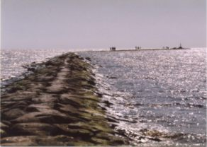
“Pärnu is a health resort of the joyous, which the state of Estonia may rightfully be proud of and what the traveller on the Baltic Sea, whichever his nationality, should pay homage to by rendering a personal visit.
By putting up in the summertime Pärnu, in the town of bright sun, salty sea, invigorating western wind, enchanting boulevards, excellent swimming opportunities, modern treatment facilities, music and friendly people, you can shake off the shadows of the tomorrow from the countenance of today’s generation, whatever the challenges posed today”. This was written in 1936. The present spa town of Pärnu attracts the young by its beaches and the ruckus of summer events, and the not so young by fresh air, mud baths, and peace and quiet. There is something for everyone’s pleasure! Pärnu is a health resort of international stature. Proof to this is the visitors arriving from around fifty countries, and the following two honours bestowed upon it: in 2000, Pärnu joined the ESPA (European Spas Association) and in 2001 Pärnu flew the European Blue Flag at its beach.

