Питер Бердж

Биография
Страна: Австралия
Штат: New South Wales
Дата рождения: 3 июля, 1974
Спорт: атлетика, прыжки в длину
Клуб: Melbourne Track Club/Sydney Pacific
Лучший орезультат: 8.30 метра
Достижения: 1998: He won the gold medal and set a new Games record at the Commonwealth Games in Kualur Lumpur
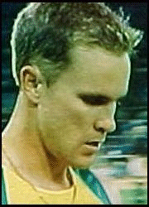
Nowhere in men’s track and field can Australia boast greater depth than in the long jump event, with a triumvirate of world class performers. That depth was underlined last year when Jai Taurima and Shane Hair finished fourth and fifth respectively at the World Championships. The third member of the trio, Peter Burge, had to watch from home as Taurima and Hair competed in Seville.
After a promising early career as a triple jumper, Burge only began long jumping in 1998. Success was immediate. He recorded a jump of 8.22cm during his first year of competition at no less an event than the Commonwealth Games final.
He won the gold medal and set a new Games record. His team-mates Taurima and Hair finished second (on a countback) and fourth respectively.
This must have made 1999 all the more difficult for Burge, as he missed the entire domestic season and the World Championships - with a chronic groin injury. Understandably, Burge was disappointed to have missed the chance to compete in Seville, but says he never lost the faith.
"It was extremely frustrating, but all the way through that I knew I would get back, no matter how long it took, I knew I’d get back and I’ve proven that to myself," he says.
"But it was hard, the guys did extremely well at the world champs but I’m looking now to get back with those guys and maybe do a little bit better."
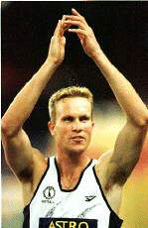His recovery has been good, and Burge recorded strong results in the lead-up to the domestic season in 2000. That form continued in the Grand Prix season proper, with Burge recording a series of eight-metre-plus leaps.
Of course, given the competition from Hair and Taurima, an eight metre jump has not been enough to ensure success for Burge, and the three of them have shared the honours domestically. But Burge won the national title in February with a big leap of 8.28m. It was the biggest jump by an Australian on home soil, and a new personal best for Burge as he beat Taurima into second place with Hair, the defending champion, in third.
But that was only a taster. Burge leapt even further at the Melbourne Track Classic, recording a jump of 8.30m. Burge says the competition has given all three confidence on the international stage.
"When we perform so well locally, we’re quite confident when we go away and we know we can produce those same sorts of performances elsewhere and take on the world’s best and hopefully beat them," he says.
If the three of them are able to continue to bring out the best in each other, Australia can realistically hope to have three competitors in the long jump final in Sydney, as all three have already qualified for the Games.

